**Project Overview:**

This Pony program finds sequences of k consecutive integers whose squares sum to a perfect square. The program uses Pony's actor model for efficient parallel computation on multi-core machines.

**How to Run:**

Make sure the pony is installed in the system, go to the directory of the project and to compile use the command ponyc.

And to run use the command .\run_lucas.ps1

**Example:**

PS D:\pony_projects\squares> .\run_lucas.ps1

Supply values for the following parameters:

N: 3

K: 2

Computation complete

Results: 3

**Work Unit Size:**

The best performance was achieved by using 16 workers, each handling a chunk size of 𝑁/16. This balance minimized overhead and ensured even distribution of work.

**Performance:**

For the input lukas 1000000 4, the program reports:

PS D:\pony_projects\squares> .\run_lucas.ps1

cmdlet run_lucas.ps1 at command pipeline position 1

Supply values for the following parameters:

N: 1000000

K: 4

Computation complete

Results:

User Time: 0 seconds

System Time: 0 seconds

Real Time: 1.0843626 seconds

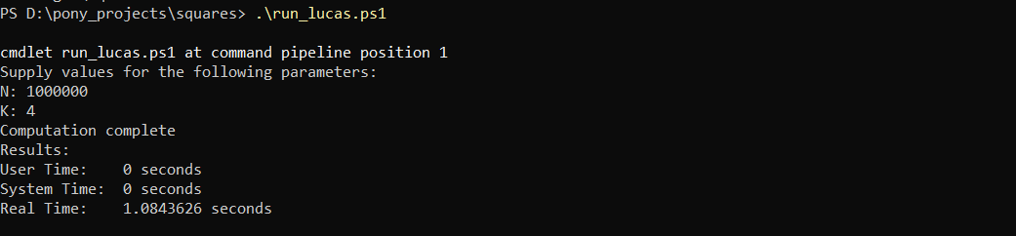

For the other inputs:

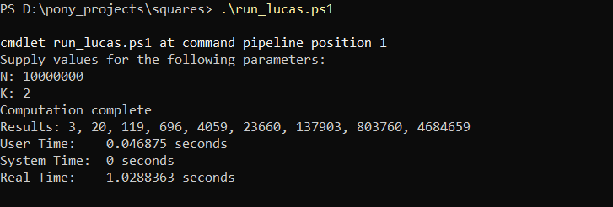

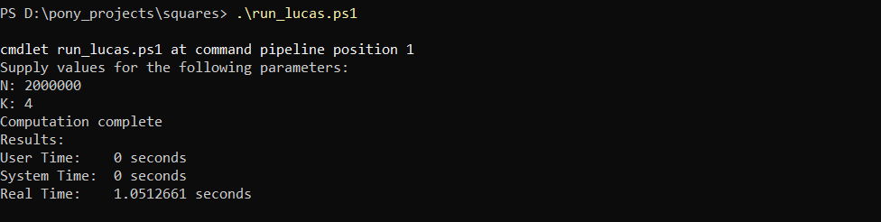

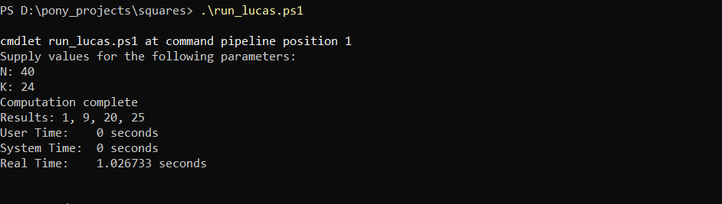

**Largest Problem Solved:**

The largest problem solved was for **N = 100000000000** and **k = 2**

